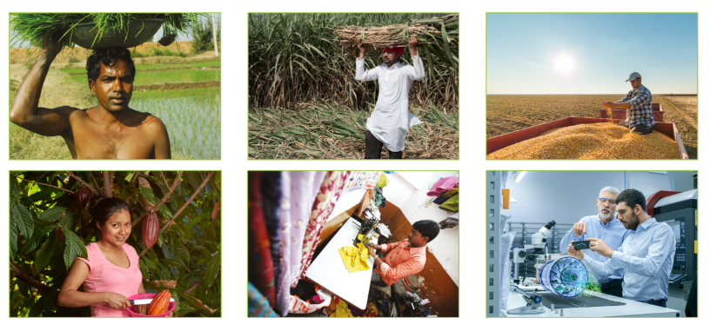
Friday 26th May
Being a Global Citizen

Discussion with your partner:
- How do goods reach us from all across the world?
- Where and how did these items start their lives?
- What do you think life is like for the people who grew /made them?
- How is your life different from that of the people who grew/made these items?
- Does the trade in food give equal benefits to people abroad who grow it and to people in this country who buy it?
