Year 6 Changing Me Unit Resources

Where Willy Went is a British children's novel written and illustrated by Nicholas Allan. The book is about a sperm named Willy who lives inside Mr Browne. Just like other 300 million sperms, Willy races trying to catch the prize, an egg.

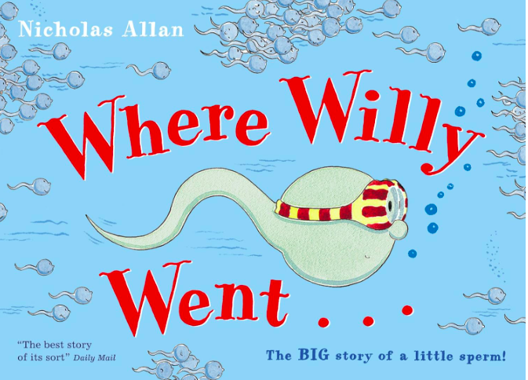

https://www.youtube.com/watch?v=H2m6k6PDtss

